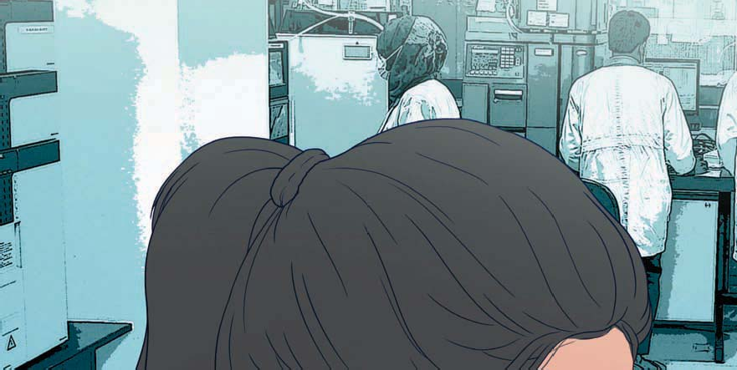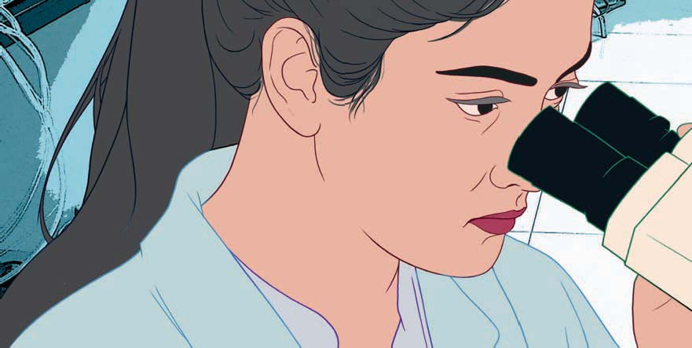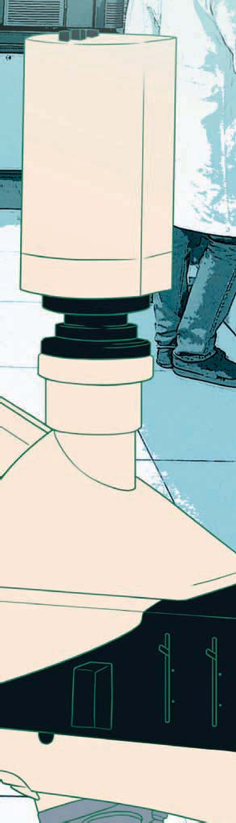

ANNUAL REPORT 2022-23

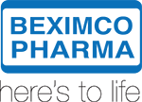

**Name: Md Awal Pramanik**

**Batch: 21**

**Date: 07-10-24**

**INDEX**

Contents

Executive Summary 3

Products and Service 4

Our Leading Brands 4

Products Launched in 2022-23 10

Business Plan 11

Sales and Cost Statistics 2022-23 12

Beximco Pharma(Consolidated) 12

Beximco Pharma (stand-alone) 13

Value Addition 14

# Executive Summary

Beximco Pharmaceuticals Limited is a leading manufacturer and exporter of medicines in Bangladesh. Incorporated in 1976, the Company initiated its operations by importing products from Bayer, Germany and Upjohn, USA, and selling them in the local market. In 1980, Beximco Pharma commenced the manufacturing of these products under licensing agreements and introduced its proprietary formulation brands in 1983. Since its modest beginnings, the Company has consistently progressed with remarkable success. Today, Beximco Pharma has become an emerging global generic pharma company in the region. The Company manufactures more than 300 products in different forms and strengths covering almost all therapeutic categories. Leveraging its state-of-the-art manufacturing facilities and research capabilities the Company earned its name as an admired manufacturer of high-quality generic medicines. The Company’s manufacturing facilities have been accredited by the leading global regulatory authorities. Beximco Pharma exports its medicines to over 50 countries including the highly regulated markets of USA, Europe, Canada, and Australia.

Beximco Pharma has received recognitions from different national and global organizations for excellence, innovation, and performance. The Company has been awarded the National Export (Gold) trophy eight times in acknowledgment of its remarkable contributions to pharmaceutical exports. It is also the winner of the highly prestigious SCRIP Award 2017 (“Best Pharma Company in an Emerging Market”), Global Generics & Biosimilar Awards 2019 (“Company of the Year, Asia Pacifi c”), CPhI Pharma Awards 2020 (“Innovation in Response to COVID-19”), and Global Generics & Biosimilar Awards 2021 (“The Company of the Year, Asia Pacifi c”). Beximco Pharma’s acquisition of Sanofi Bangladesh Limited in 2021 helped it win the Global Generics & Biosimilar Awards 2022(“Acquisition of the Year”).

The Company holds 85.2% stake in Nuvista Pharma Limited (formerly Organon Bangladesh), a leading unlisted pharmaceutical company in Bangladesh specializing in hormone and steroid drugs. In October 2021, it acquired a controlling interest of 54.6% in Sanofi Bangladesh Limited from the Sanofi Group represented through May & Baker Limited and Fisons Limited. Subsequent to this acquisition the company was renamed as Synovia Pharma PLC.

The Company holds 85.2% stake in Nuvista Pharma Limited (formerly Organon Bangladesh), a leading unlisted pharmaceutical company in Bangladesh specializing in hormone and steroid drugs. In October 2021, it acquired a controlling interest of 54.6% in Sanofi Bangladesh Limited from the Sanofi Group represented through May & Baker Limited and Fisons Limited. Subsequent to this acquisition the company was renamed as Synovia Pharma PLC.

# Products and Service

Beximco Pharma currently produces more than 300 generics available in well over 500 presentations. It’s portfolio encompasses wide range of therapeutic categories namely antibiotics, analgesics, anti-diabetics, respiratory, cardiovascular, central nervous system, dermatology, gastrointestinal, anti-cancers etc.

The Company has consistant leadership in several of its brands including Napa, Napa Extra, Neofl oxin, Atova, Azmasol, Arlin, Bexitrol F, D-Rise, Bizoran, Amdocal, Remmo, Tofen, Tyclav etc. It has sound expertise with specialized and advanced drug delivery systems such as metered dose inhalers, dry powder inhalers, nasal sprays, sterile ophthalmic, lyophilized injectables, oral thin fi lms, suppositories etc. Beximco Pharma continuously strives to focus on expanding and diversifying its product portfolio in order to ensure that people have access to newer and better treatment options at an affordable cost. The expanding portfolio, includes high value, differentiated, and diffi cult to copy products, which contributes as a growth driver to the Company.

Alongside the formulation products, Beximco Pharma also produces several Active Pharmaceutical Ingredients (APIs) for its captive consumption as well as selling to other pharmaceutical manufacturers. The Company is now working on strengthening the API portfolio and its current pipeline includes a number of patented, high value products.

## Our Leading Brands

|  |  |  |  |  |
| --- | --- | --- | --- | --- |
| Analgesics |  | NAPA | Tablet | Paracetamol 500 mg |
|  |  | Suppository | Paracetamol 125 mg, 250 mg and 500 mg |
|  | CHILDREN'S NAPA | Syrup  Suspension Drops | Paracetamol 120 mg / 5 ml  Paracetamol 120 mg / 5 ml Paracetamol 80 mg / m |
|  | NAPA IV | Injection | Paracetamol 10 mg / ml |
|  | NAPA ONE | Tablet | Paracetamol 1000mg |
|  | NAPA EXTRA | Tablet | Paracetamol 500 mg + Caffeine 65 mg |
|  | NAPA EXTEND | Tablet | Paracetamol 665 mg Extended Release |
|  | NAPADOL | Tablet | Paracetamol 325 mg + Tramadol 37.5 mg |
|  | NAPA RAPID | Tablet | Paracetamol 500 mg (with Actizorb technology) |
| Joint Supplement |  | JOINTEC MAX | Tablet | Glucosamine 750 mg + Diacerein 50 mg |
| Muscle Relaxant |  | RELENTUS | Tablet | Tizanidine 2 mg |
| NSAIDs |  | DINOVO | Tablet | Naproxen 375 mg + Esomeprazole 20 mg, Naproxen 500 mg + Esomeprazole 20 mg |
|  | VOLIGEL | Cream | Diclofenac Sodium 1% 50 mg |
|  | XIDOLAC | Tablet | Ketorolac Tromethamine 10 mg |
|  |  | Meltab | Ketorolac Tromethamine 10 mg |
|  |  | Injection | Ketorolac Tromethamine 30 mg / ml |
|  | BUFLEX | Tablet | Nabumetone 500mg and 750mg |
| Anti-Hypertensives  Lipid Lowering  Heart Failure  Oral Anticoagulants  Low Molecular  Heparin  Anti-Platelets  Cerebral Vasotherapeutics  Contrast Agent  Anti-Infectives |  | LEVAMDOCAL | Tablet | Levamlodipine 1.25 mg, Levamlodipine 2.5 mg, Levamlodipine 5 mg |
|  | BETAPRO | Tablet | Bisoprolol Hemifumarate 2.5 mg, Bisoprolol Hemifumarate 5 mg, Bisoprolol Hemifumarate 10 mg |
|  | AMDOCAL PRO | Tablet | Bisoprolol Fumarate 2.5 mg + Amlodipine Besilate 5 mg |
|  | ATOVA EZ | Tablet | Atorvastatin 10 mg + Ezetimibe 10 mg, Atorvastatin 20 mg + Ezetimibe 10 mg, |
|  | TELMA | Tablet | Telmisartan 40 mg, Telmisartan 80 mg |
|  | TELMACAL | Tablet | Telmisartan 40 mg + Amlodipine 5 mg, Telmisartan 80 mg + Amlodipine 5 mg |
|  | TELMA PLUS | Tablet | Telmisartan 40 mg + Hydrochlorothiazide 12.5 mg |
|  | CARDOCAL | Tablet | Cilnidipine 5 mg, Cilnidipine 10 mg |
|  | NITROSOL | Spray | Glyceryl Trinitrate 400 mcg |
|  | PACET | Tablet | Amiodarone Hydrochloride 100 mg, Amiodarone Hydrochloride 200 mg |
|  | PROSAN | Tablet | Losartan Potassium 25 mg, Losartan Potassium 50 mg |
|  | PROSAN HZ | Tablet | Losartan Potassium 50 mg, Hydrochlorothiazide 12.5 mg |
|  | ATOVA | Tablet | Atorvastatin 10 mg, Atovastatin 20 mg, Atovastatin 40 mg |
|  | ATOVA EZ | Tablet | Atorvastatin 10 mg+ Ezetimibe 10 mg, Atorvastatin 20 mg+ Ezetimibe 10 mg |
|  | CIBRATE | Tablet | Ciprofibrate 100 mg |
|  | ROSUTIN | Tablet | Rosuvastatin 5 mg, Rosuvastatin 10 mg, Rosuvastatin 20 mg |
|  | VIVANTA | Tablet | Sacubitril 24 mg+ Valsartan 26 mg, Sacubitril 49 mg+ Valsartan 51 mg, Sacubitril 97 mg+ Valsartan 103 mg, |
|  | APIXA | Tablet | Apixaban 2.5 mg, Apixaban 5 mg |
|  | KINEXA | Tablet | Rivaroxaban 2.5 mg, Rivaroxaban 10 mg, Rivaroxaban 15 mg |
|  | CLEVEN | Injection | Enoxaparin Sodium 20 mg/0.2 ml, Enoxaparin Sodium 40 mg/0.4 ml, Enoxaparin Sodium 60 mg/0.6 ml, Enoxaparin Sodium 80 mg/0.8 ml |
|  | ODREL PLUS | Tablet | Clopidogrel 75 mg + Aspirin 75 mg |
|  | TIGEL | Tablet | Ticagrelor 90 mg |
|  | CITICOL | Injection | Citicoline 500 mg/4 ml |
|  | LOPIDAM | Injection | Lopamidol 370 mg/ml |
|  | LOPIDAM | IV Infusion | Lopamidol 370 mg/ml |
|  | ARLIN | Tablet Suspension  Injection | Linezolid 400 mg, Linezolid 600 mg  Linezolid 100 mg / 5 ml Linezolide 2 mg / ml IV Infusion |
|  | TRIOCIM | Capsule  Suspension | Cefixime 200 mg, Cefixime 400 mg  Cefixime 100 mg / 5 ml, Cefixime 200 mg / 5 ml |
|  | TYCLAV | Tablet  Suspension Injection | Amoxicillin 250mg + Clavulanic Acid 125 mg, Amoxicillin 500 mg + Clavulanic Acid 125 mg, Amoxicillin 750 mg + Clavulanic Acid 125 mg  Amoxicillin 125 mg + Cavulanic Acid 31.25 mg / 5 ml, Amoxicillin 400 mg + Clavulanic Acid 57 mg / 5 ml  Amoxicillin 1 Gm + Clavulanic Acid 200 mg, Amoxicillin 500 mg + Clavulanic Acid 100 mg |

|  |  |  |  |  |
| --- | --- | --- | --- | --- |
| Anti-Infectives |  | TURBOCLAV | Tablet | Cefuroxime 250 mg + Clavulanic Acid 62.5 mg, Cefuroxime 500 mg + Clavulanic Acid 125 mg |
|  | AZITHROCIN | Tablet  Suspension Injection | Azithromycin 250 mg, Azithromycin 500 mg  Azithromycin 200 mg / 5 ml Azithromycin 500 mg IV |
|  | FILMET | Tablet  Syrup | Metronidazole 200 mg, Metronidazole 400 mg, Metronidazole 800 mg  Metronidazole 200 mg / 5 ml |
|  | NEOFLOXIN | Tablet Injection  Suspension | Ciprofloxacin 750 mg, Ciprofloxacin 500 mg, Ciprofloxacin 250 mg  Ciprofloxacin 250 mg / 5 ml  Ciprofloxacin 250 mg / 5 ml |
|  | ARIXON | Injection (IV)  Injection (IM) | Ceftriaxone Sodium 250 mg, Ceftriaxone Sodium 500 mg, Ceftriaxone Sodium 1 gm, Ceftriaxone Sodium 2 gm  Ceftriaxone Sodium 250 mg, Ceftriaxone Sodium 500 mg, Ceftriaxone Sodium 1 gm |
|  | FOSAMIN | Sachet | Fosfomycin Trometamol 3 gm |
|  | PENOMER | Injection | Meropenem Trihydrate 500 mg, Meropenem Trihydrate 1 gm |
|  | BEXOVID | Tablet | Nirmatrelvir 150 mg + Ritonavir 100 mg |
|  | BEMSIVIR | Injection | Remdisivir Inn 100 mg, Remdisivir Inn 100mg Lyophilized Powder |
|  | EMORIVIR | Capsule | Monlupiravir 200 mg |
|  | MULINA | Tablet  Injection | Lefamulin 600 mg  Lefamulin 150 mg/15 ml |
|  | BEMSIVIR | Injection | Remdisivir Inn 100 mg |
|  | EMORIVIR | Capsule | Monlupiravir 200 mg |
| Antacids |  | PROGAVI | Suspension | Sodium Alginate 500 mg + Sodium Bicarbonate 213 mg + Calcium Carbonate 325 mg |
| Anti-Ulcerants |  | ACIFIX | Tablet | Rabeprazole 20 mg |
|  | REMMO | Tablet | Esomeprazole 20 mg, Esomeprazole 40 mg |
|  | GASTALFET | Tablet  Suspension | Sucralfate 500 mg, Sucralfate 1000 mg  Sucralfate 1 mg/ 5 ml |
| Gastroprokinetics |  | DEFLUX | Tablet Suspension  Drops | Domperidone 10 mg, Domperidone 10 mg Meltab Domperidone 5 mg / 5 ml  Domperidone 5 mg / ml |
|  | MOPRIDE | Tablet | Prucalopride Succinate 1 mg, Prucalopride Succinate 2 mg |
| CNS |  | FRENXIT | Tablet | Flupentixol 0.5 mg + Melitracen 10 mg |
|  | NERVALIN | Capsule  Oral Solution | Pregabalin 25 mg, Pregabalin 50 mg, Pregabalin 75 mg  Pregabalin 100 mg/5 ml |
|  | NERVALIN CR | Tablet | Pregabalin 82.5 mg CR, Pregabalin 165 mg CR, Pregabalin 330 mg CR, |
|  | XETRIL | Tablet | Clonazepam .5 mg, Clonazepam 2 mg |
|  | EMIJOY | Tablet | Chlordiazepoxide 5 mg + Amitriptyline Hcl 12.5 mg |
| Hormones and Steroids |  | TAMONA | Tablet | Tamoxifen Citrate 10 mg,Tamoxifen Citrate 20 mg |

|  |  |  |  |  |  |  |  |  |  |
| --- | --- | --- | --- | --- | --- | --- | --- | --- | --- |
| Anti-Fungals | | |  | OMASTIN | | Capsule Suspension  Injection | | Fluconazole 150 mg, Fluconazole 200 mg, Fluconazole 50 mg  Fluconazole 50 mg / 5 ml Fluconazole 2 mg / ml Infusion | |
|  | TERBEX | | Tablet  Cream (5 gm)  Cream (10 gm) | | Terbinafine 250 Mg  Terbinafine HCI 1%  Terbinafine HCI 1% | |
|  | LULEXA | | Cream (10 gm)  Cream (20 gm) | | Luliconazole INN 10 mg/gm  Luliconazole INN 10 mg/gm | |
|  | RESOLVE | | Shampoo | | Ketoconazole 2% | |
| Steroids | | |  | EXOVATE N | | Cream  Ointment | | Clobetasol Propionate 0.05% + Neomycin 0.35% + Nystatin 1,00,00,000 Units  Clobetasol Propionate 0.05% + Neomycin 0.35% + Nystatin 1,00,00,000 Units | |
| Respiratory | | |  | AZMASOL | | MDI | | Salbutamol 100 mcg / Puff | |
|  | | |  | | DPI | | Salbutamol 200 mcg / Capsule | |
|  | | |  | | Respules | | Salbutamol 2.5 mg / 3 ml Ampoule | |
|  | | |  | | Respirator Solution | | Salbutamol 2.5 mg / 3 ml Ampoule, Salbutamol 5 mg / ml in amber glass bottle | |
|  | | |  | BEXITROL-F | | MDI | | Salmetarol 25 mcg + Fluticasone Propionate 125 mcg, Salmetarol 25 mcg + Fluticasone Propionate 250 mcg, Salmeterol 25 mcg + Fluticasone Propinate 50 mcg | |
|  | | |  | | DPI | | Salmetarol 50 mcg + Fluticasone Propionate 100 mcg, Salmetarol 50 mcg + Fluticasone Propionate 200 mcg, Salmeterol 50 mcg + Fluticasone Propinate 500 mcg | |
|  | | |  | | MAXHALER | | Salmetarol 50 mcg + Fluticasone Propionate 100 mcg, Salmetarol 50 mcg + Fluticasone Propionate 200 mcg, Salmeterol 50 mcg + Fluticasone Propinate 500 mcg | |
|  | | |  | SYMBION | | DPI | | Formoterol Fumarate 6 mcg + Budesonide 100 mcg, Formoterol Fumarate 6 mcg + Budesonide 200 mcg | |
|  | | |  | | MDI | | Formoterol Fumarate 4.5 mcg + Budesonide 80 mcg, Formoterol Fumarate 4.5 mcg + Budesonide 160 mcg | |
|  | | |  | | MAXHALER | | Formoterol Fumarate Dihydrate 12 mcg + Budesonide 400 mcg | |
|  | | |  | TIORIVA | | DPI | | Tritropium Bromide 18 mcg | |
|  | | |  | UPTECH GO | | Device | | Device for MDI Adult Device for MDI Child | |
|  | | |  | IPRASOL | | MDI | | Salbutamol 100 mcg+ Ipratropium 20 mcg | |
|  | | |  | | Respules | | Salbutamol 2.5 mg+ Ipratropium 0.5 mg/ 3 ml | |
|  | | |  | | Respirator Solution | | Salbutamol 2.5 mg/ml+ Ipratropium 0.5 mg/ml | |
|  | | |  | FLOMYST F | | MDI | | Fluticasone Propionate 5 mcg + Formoterol Fumarate 50 mcg, Fluticasone Propionate 5 mcg + Formoterol Fumarate 125 mcg, Fluticasone Propionate 10 mcg + Formoterol Fumarate 250 mcg | |
|  | | |  | ONRIVA PLUS | | DPI | | Indacaterol 110 mcg + Glycopyrronium 50 mcg | |
|  | | |  | ONRIVA TRIO | | DPI | | Indacaterol 150 mcg+ Glycopyrronium 50 mcg+ Mometasone Furoate 160 mcg | |
|  | | |  | TRIBREZ | | Inhaler | | Formoterol Fumarate BP5.5 mcg + Glycopyrro | |
|  | | |  | BILEXA | | DPI | | Fluticasone Furoate Inn 100 mcg & Vilantero 25 mcg Fluticasone Furoate Inn 200 mcg & Vilantero 25 mcg | |
| Respiratory | |  | BEXIHALER (MORA) | | | Device | | Device for DPI | |
|  | |  | PULMIDONE | | | Tablet | | PIRFENIDONE BP 267 MG PIRFENIDONE BP 801 MG | |
| IV Fluids | |  | DEXAQUA | | | Injection | | Dextrose 10% W/V, Dextrose 5% W/V | |
|  | |  | DEXORIDE | | | Injection | | NaCl 0.9% W/V & Dextrose 5% W/V | |
|  | |  | SALORIDE | | | Injection | | Sodium Chloride 0.09% W/V | |
| Ophthalmic | |  | ODYCIN D | | | Eye Drops | | Moxifloxacin Hcl | |
|  | |  | TEARON PF | | | Eye Drops | | Polyethylene Glycol 400 0.4% + Propylene Glycol 0.3% | |
|  | |  | TEARON FRESH | | | Eye Drops | | Caboxymethyl Cellulose Sodium 1% | |
|  | |  | NEOFLOXIN | | | Eye Drops | | Ciprofloxacin 0.3% | |
|  | |  | NEOFLOXIN D | | | Eye Drops | | Ciprofloxacin 0.3% + Dexamethasone 0.1% | |
| Urogenital | |  | URAL-K | | | Solution | | Potassium Citrate 1500 mg + Citric Acid Monohydrate 250 mg / 5 ml Solution | |
|  | |  | MIRASOL | | | Tablet | | Mirabegron INN 25 mg, Mirabegron INN 50 mg | |
|  | |  | UROFLO | | | Capsule | | Tamsulosin Hydrochloride 0.4 mg | |
| Bio-Similar | |  | OGIVRI | | | Lyophilized Powder | | Trastuzumeb INN 440mg/Vial | |
| Oncology | |  | XELOCIN | | | Tablet | | Capecitabine 500 mg | |
|  | |  | PACLI | | | IV Infusion | | Paclitaxel 6 mg/ml | |
|  | |  | TINICEV | | | Tablet  Tablet | | Imaitnib 400 mg Tablet  Imaitnib 100 mg Tablet | |
| Vitamins & Minerals | |  | BEXTRAM GOLD | | | Tablet | | High Potency 32 Multivitamin-Mineral | |
|  | |  | BEXTRAM SILVER | | | Tablet | | High Potency 30 Multivitamin-Mineral | |
|  | |  | D-RISE | | | Capsule | | Cholecalciferol 20000 IU, Cholecalciferol 40000 IU | |
|  | |  |  | | | Tablet | | Cholecalciferol 2000 IU | |
|  | |  |  | | | Chewable | | Cholecalciferol 1000 IU | |
|  | |  |  | | | Tablet | |  | |
|  | |  |  | | | Oral Solution | | Cholecalciferol 2000 IU/ ml | |
|  | |  | HEMOFIX FZ | | | Tablet | | Elemental Iron 48 mg (Ferrous Ascorbate), Folic Acid 0.5 mg And Elemental Zinc 22.5 mg Tab | |
|  | |  | NEUROCARE | | | Tablet | | Vitamin B1, B6, and B12 | |
|  | |  | FERINTUS | | | Injection | | Ferric Carboxymaltose 500 mg/10 ml, Ferric Carboxymaltose 100 mg/2 ml | |
|  | |  | BECORAL D | | | Tablet | | Coral Calcium | |
|  | |  | BECORAL DX | | | Tablet | | Coral Calcium | |

|  |  |  |
| --- | --- | --- |
| Active Pharmaceutical Ingredients (APIs) |  | APIXABAN |
|  | DICLOFENAC |
|  | LINAGLIPTIN |
|  | PENICILLINS Amoxicillin Floxacillin Flucloxacillin |
|  | RIVAROXABAN |
|  | ROSUVASTATIN |
|  | SITAGLIPTIN |

***For more details visit our website:*** [BEXIMCO PHARMACEUTICALS LIMITED](https://beximcopharma.com/)

## Products Launched in 2022-23

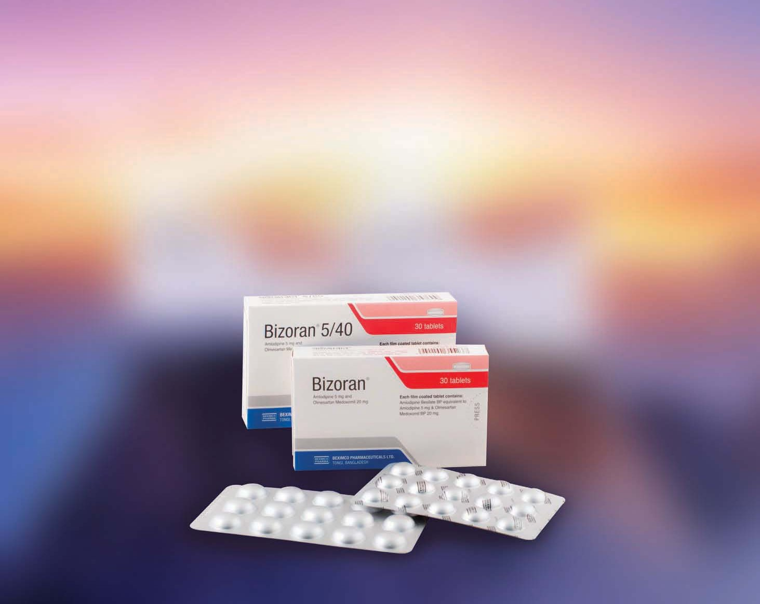

Beximco Pharma launched 14 generics in 23 different presentations in the domestic market during 2022-23. Mulina (Lefamulin) an anti-infective drug was introduced for the first time in Bangladesh. In the first quarter of 2023-24, the Company further strengthened its product basket with introduction of 15 new generics (22 presentations) in the domestic markets, 10 of them being first time in Bangladesh.

# Business Plan

We will be one of the most trusted, admired and successful pharmaceutical companies in the region with a focus on strengthening research and development capabilities, creating partnerships and building presence across the globe.

# Sales and Cost Statistics 2022-23

## Beximco Pharma(Consolidated)

BDT 34,699.2m

Net sales

BDT 39,266.7m 13.3%

Domestic sales

BDT 31,984.1m

BDT 36,503.5m 14.1%

EPS

Profit after tax

Profit before tax

Gross Profit

Export sales

BDT 91.01m

BDT 11.48m

BDT 4,998.6m

BDT 6,686.9m

BDT 15,820.2m

BDT 2,685.1m

NAVPS

BDT 97.91 7.6%

BDT 10.34 9.9%

BDT 4,524.5m 9.5%

BDT 6,068.8m 9.2%

BDT 17,313.4m 9.4%

BDT 2,763.2m 2.9%

## Beximco Pharma (stand-alone)

**2022-23**

BDT 30,220m

Net sales

BDT 39,991m 9.2%

Domestic sales

BDT 27,553.6m

BDT 30,238m 9.7%

EPS

Profit after tax

Profit before tax

Gross Profit

Export sales

BDT 90.37m

BDT 11.57m

BDT 5,161.3m

BDT 6,736.5m

BDT 13,712.8m

BDT 2,667.2m

NAVPS

BDT 97.15 7.5%

BDT 10.28 11.1%

BDT 4,588.0m 11.1%

BDT 5,897.3m 12.5%

BDT 14,520m 5.9%

BDT 2,753m 3.2%

35% Cash Dividend for 2022-23

## Value Addition

Amounin Million Taka

|  |  |  |  |  |
| --- | --- | --- | --- | --- |
| **2022-23** | |  | **2021-22** |  |
| **Taka** | | **%** | **Taka** | **%** |
| **Value Added:** | | | | |
| Sales & Other Income | 46,053 | 41,301 | | |
| Bought-in-Materials & Services | (22,186) | (19,074) | | |
|  | **23,867** | **22,227** | | |
| **Applications:** | | | | |
| Salaries and Benefits to Employees | 6,705 | 28.1% | 6,035 | 27.% |
| Interest to Lenders | 1,286 | 5.4% | 1,002 | 4.5% |
| Duties & Taxes to Govt. Exchequer | 9,215 | 38.6% | 8,028 | 36.% |
| Dividend to Shareholders | 1,645 | 6.9% | 1,608 | 7.2% |
| Retained by the Company | 5,016 | 21.0% | 5,554 | 25.% |
| **23,867 100% 22,227 100%** | | | | |